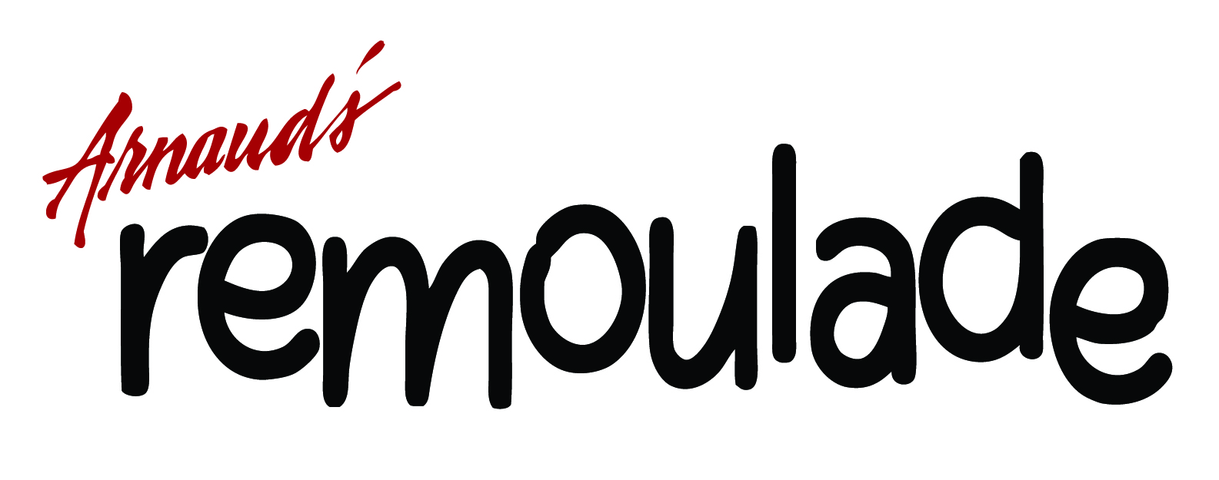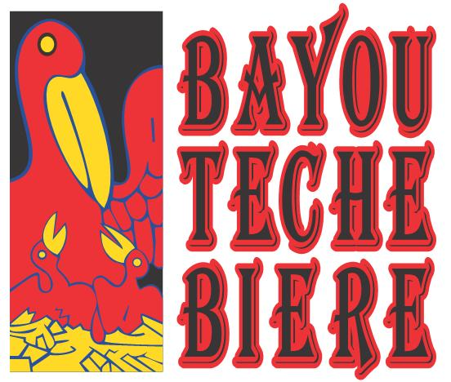

CONTACT: Carrie DeVries FOR IMMEDIATE RELEASE

Deveney Communication

(504) 949-3999, ext. 209

cdevries@deveney.com

REMOULADE RESTAURANT AND BAYOU TECHE BIERE JOIN FORCES FOR FIRST EVER
B(ROUX) TASTING
(NEW ORLEANS) – November 11, 2013 – What do you get when you mix Remoulade’s signature gumbos (it’s all in the roux!) with the nationally acclaimed and Louisiana-based brews of Bayou Teche Biere? The first ever B(Roux)TM Tasting at Remoualde Restaurant, Tuesday, December 3 at 6:30 p.m.

Guests will enjoy five courses of Remoulade’s authentic Cajun cuisine, complemented by the latest and greatest bieres of Bayou Teche Brewery. The event will also feature live music by Louis Michot of the Lost Bayou Ramblers.

“In Louisiana, we take our food seriously. No other region can tout a cuisine as complex, varied or elegant as ours,” said Karlos Knott, Brewmaster of Bayou Teche Brewery. “Partnering with Remoulade is a natural fit for our brewery, since our bieres are crafted to complement Cajun cuisine, which Remoualde is so celebrated for.”

The menu includes:
Hors D’Oeuvres
La 31 Passionné
Shrimp Corndogs
Boudin Wontons
Fried Shrimp served with Cocktail and Arnaud Sauces

Dinner
LA 31 Bière Pâle
Stuffed Crabs

Acadie
Filé Gumbo
LA 31 Boucanée
Rabbit and Tasso Gumbo

Dessert
La 31 Bière Noir
Bûche de Noël

“The B(roux) Tasting is sure to be a cultural experience, blending a perfect trinity of traditional Cajun cuisine, music and of course, beer,” said Archie Casbarian, co-owner of Remoulade Restaurant.
The cost to attend the B(Roux) Tasting at Remoulade is $30 (plus tax and gratuity). For reservations, call (504) 523-5433. Space is limited.

Remoulade Restaurant is located on 309 Bourbon Street. The restaurant is open daily from 11:30 a.m. to 11:00 p.m. For more information and to view the entire menu, visit www.remoulade.com.

###

About Remoulade
Remoulade – the casual side of Arnaud’s – is a family friendly café located at 309 Bourbon Street. With two entrances opening up to Bourbon Street, Remoulade offers accessible Creole cuisine just steps from New Orleans’ legendary street party.

The menu boasts Arnaud’s signature dishes, like Shrimp Remoulade, alongside unique New Orleans delicacies, such as po-boys, jambalaya, red beans and rice, and fresh oysters from the oyster bar.

About Bayou Teche Brewing
Bayou Teche Brewing was founded in 2009 on a simple dream – to craft beers that complement the cuisine and lifestyle of Cajuns and Creoles. With that mission in mind, the Knott brothers decided to convert an old railcar into a farmhouse brewery on the banks of the scenic Bayou Teche. Bayou Teche Brewery is located 1002 Noth Lane in Arnaudville, Louisiana.

Bayou Teche Biere has recently been featured on The Chew, Anthony Bourdain and The Food Network for their uniquely crafted bieres. For more information, visit http://bayoutechebrewing.com/.

